Project Name:
Student Management Application

Date: <<03-01-2023>>

Copyright Notice
This document contains proprietary information of HCL Technologies Ltd. No part of this document may be reproduced, stored, copied, or transmitted in any form or by means of electronic, mechanical, photocopying or otherwise, without the express consent of HCL Technologies. This document is intended for internal circulation only and not meant for external distribution.

Revision History

Version No | Date | Prepared by / Modified by | Significant Changes
1.1 | 03-01-2023 | Ganesh Ronanki | N/A

Table of Contents

1.1 Project Overview 3
1.2 Scope 3
1.3 Out of Scope 3
1.4 Intended Audience 3
1.5 Usecase details 3
1.6 Technical Detailed Description 3
1.7 Database Entity Relationship Diagram 3
1.8 Standards 3

- Project Overview

Student Management Application consists of Modules-Add Student, show all Students, Get the Student based on the roll number, Delete Student, Update Student and Exit. Each module runs accordingly as the user want to function the application. This application helps the user to make the list of students including their details in the database and they will be able to recollect whenever they need.

- Scope

It includes Functional testing, it is one of the testing that seeks to establish whether each and every feature works as per the user software requirements. Each function is compared to the corresponding requirement to ascertain whether its output is consistent with the end user’s expectations.

Module Name | Applicable Roles | Description
Adding Students | Admin | Admin adds the students in database.
Displaying Students | Admin, User | Admin will be able to see the students in database
Deletion of Students | Admin | Admin can delete a student from database.
Updating Students | Admin | Admin can update the student details.

- Out of Scope

Non-functional testing like stress and performance testing, it verifies the way software works-and how well it works. Whereas functional testing verifies what software does. It checks things that aren’t covered in functional tests. Non-functional testing is just as important as functional testing.
Automation testing saves the time, makes the process quicker. This kind of testing helps to find the human errors and also it controls the flow of the execution of tests as per the written test scripts.

- Intended Audience

The document is intended for all the stake holder’s customer and the developer (designers, testers, maintainers). The user is assumed to have the basic knowledge about student management and understand the details according to their choice.

- Use cases detailed
- Add Student-In this module the user can add the student details (name, Standard, school/College, city, percentage) and he can save it.
- Show all Students-If the user wants to view the student details that he saved, this module helps in it.
- Get the Student based on the roll number-This module helps the user to get the details of an individual by the roll number itself.
- Delete Student-This module helps in delete student details.
- Update Student-In this module user can make changes in the student details accordingly.

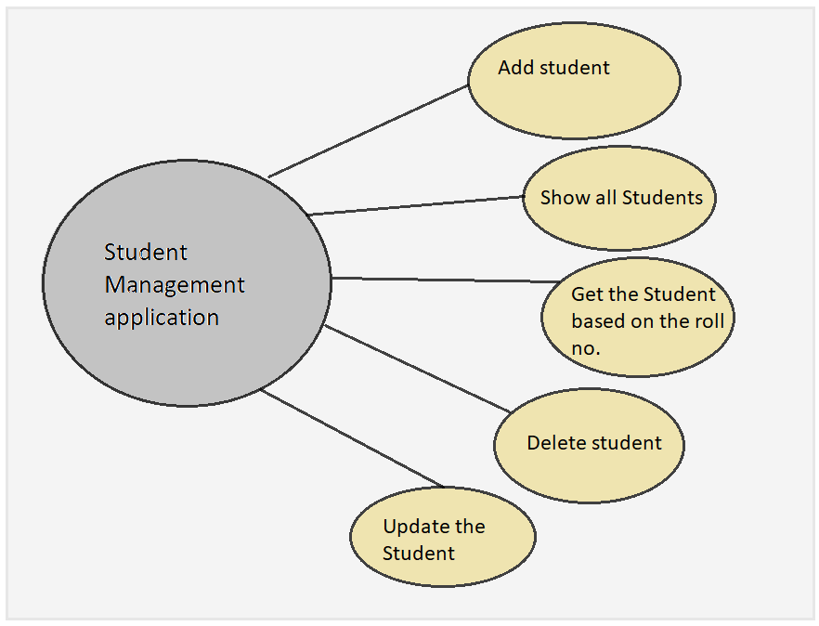

- Technical Detailed Description

Add Student-
In this module, user can add the student details accordingly. It asks the details like Enter Student Name, Enter Student standard, Enter the Student School/College, Enter City and Enter percentage. After entering each and every details about the student, student details will be stored successfully in the database (MySQL) and it displays the message “Record Inserted Successfully!!!”
Show all Students-
This module helps the user to review the students that he saved in database accordingly. Whenever the user chooses this module then the process will take place with help of database connection to collect data that have been stored in the system through the application. It show the Student details with white spaces.
Get the Student based on the roll number-
This module helps the user to get the student details by roll number. Instead of writing the name to get the details of an individual student, user can enter any integer. The details that are stored under an integer in the database will be displayed in the result.
Delete Student-
This module helps the user to delete the details of an individual student. This condition may occur, if the student get transferred or qualified from the institution, then this module can be used in this application. After deleting the record of the student it displays the message “Record Deleted successfully”.
Update Student-
In this module user can update in any detail like name, school/college, city, standard of the student then he can make the changes in those details. The updating will be done in the database itself and it displays the message “Updated successfully”.

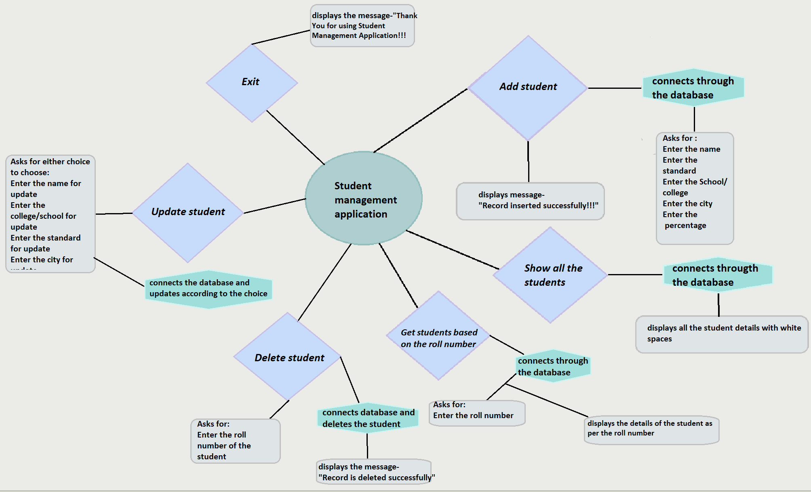

- Database Entity Relationship Diagram

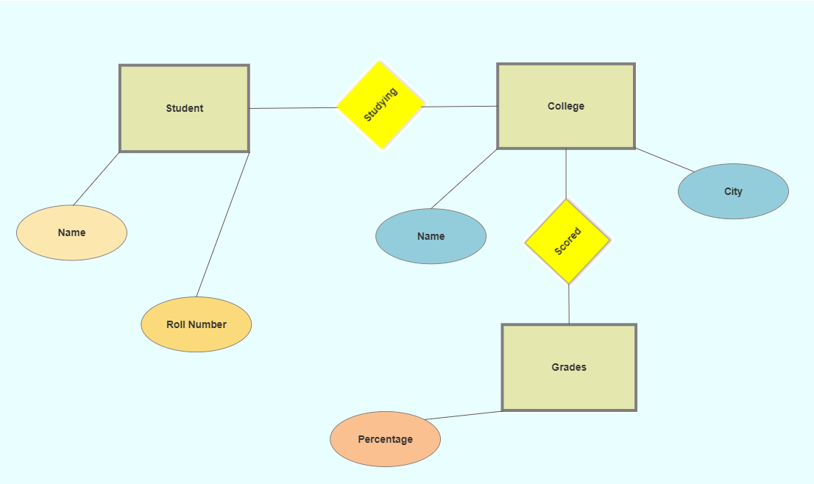

- Standards

- Class names start with an upper case letter. Variable name start with a lower case letter.
- Use descriptive and appropriate name for all identifiers (variables, method, names, class names, constants, etc.).
- Open braces (i.e. “{”) do not start a new line. Close braces (i.e. “}”) do start a new line, and are intended with the code they close
- Put single space before every “{”.
- Avoid the use of the default package
- Comment every 3-7 lines of code.
- Multi-word identifiers are internally capitalized.
- Do not use hyphens or underscores to separate multi-word identifiers (except for constants, which have all upper case letters).
- In-line comments should be used to explain complicated sections of code, such as loops. Use the // comment delimiter for in-line comments. Do not comment generally known features of the java language.
- Use two blank lines to separate each method within a class definition. Use one blank line to separate logical sections of code within a method.

